Lab 07: Auditing Program Binaries

CYBR 688: Software Reverse Engineering

Team Members: Sairam Bokka, Ethan Hart

Introduction:
In this lab, we will exploit a server containing a memory disclosure vulnerability. Its purpose is to protect a secret message shared only with those knowing the login credentials. An authenticated user may get and set the secret message but the memory disclosure vulnerability may help us find credentials and find the secret.

Materials:
-Licensed copy of Linux (Ubuntu Virtual Machine used for this lab)
-Ghidra suite for dynamic analysis
-Python3 installed on your machine
-Vulnerable server binary
-Client-side API and functional test

Understanding the test client and vulnerable server binary:
- For understanding the vulnerable server, we will run the server and run test_client.py file which connects to the server and performs a few tests on the server.
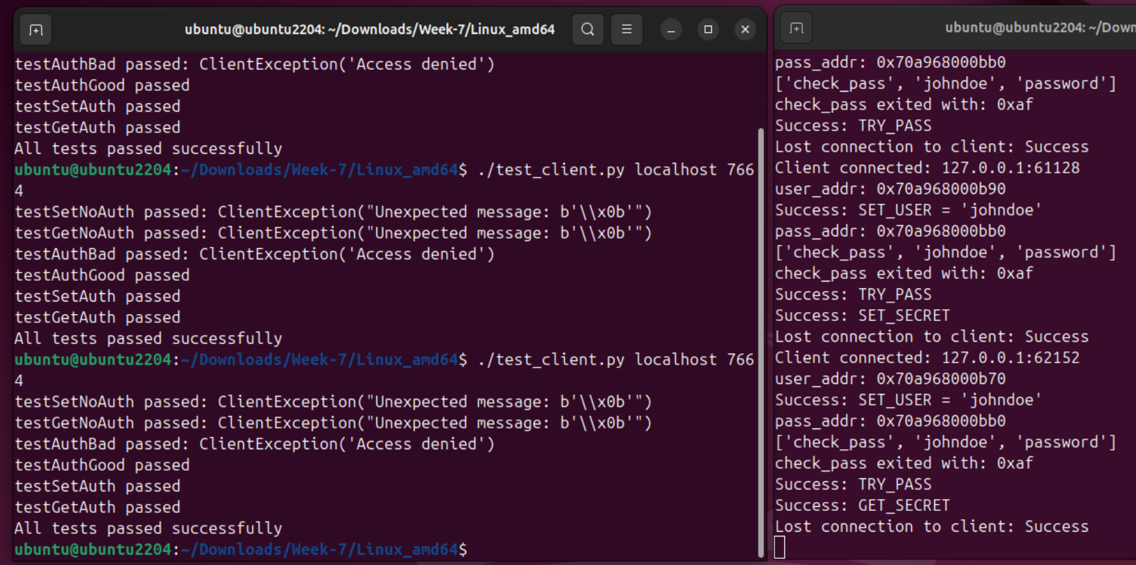
- As we can see in the figure, the test client performs a few authentication tests on the server which were completed successfully.
- The server prints out debug information about the connections made by the client and functions used by the client in the server. In this case, it is using SET_USER, GET_USER, TRY_PASS, SET_SECRET, GET_SECRET. It prints out addresses of username and password. It also invoks a sub process called check_pass, which it might be using to check the username and password provided to the server.

Protocol Documentation
The protocol uses specific message types with byte structures to manage user authentication and secret handling. All messages have a predefined structure with fields like size, username, password, and secret. Messages are exchanged in Little-Endian (LE) format for multi-byte values.

Commands
1. SET_USER
- Purpose: Set the username on the server.
- Direction: Client → Server (C → S)
- Structure:
  - type: 0
  - length: 2 bytes (LE) indicating the length of username.
  - username: Variable-length UTF-8 string.
- Response:
  - Direction: Server → Client (S → C)
  - type: 6 (Echoed)
  - username: The same username as provided by the client.

2. TRY_PASS
- Purpose: Attempt to authenticate with a password.
- Direction: Client → Server (C → S)
- Structure:
  - type: 2
  - length: 2 bytes (LE) indicating the length of password.
  - password: Variable-length UTF-8 string.
- Responses:
  - If Password is Correct:
    - Direction: Server → Client (S → C)
    - type: 8 (Access Granted)
  - If Password is Incorrect:
    - Direction: Server → Client (S → C)
    - type: 7 (Access Denied, Disconnect)

3. SET_SECRET
- Purpose: Set a secret on the server.
- Direction: Client → Server (C → S)
- Structure:
  - type: 3
  - size: 2 bytes (LE) indicating the size of secret.
  - secret: Variable-length data.
- Response:
  - Direction: Server → Client (S → C)
  - type: 9 (Acknowledgment)

4. GET_SECRET
- Purpose: Retrieve the previously set secret.
- Direction: Client → Server (C → S)
- Structure:
  - type: 4
  - size: 2 bytes (LE) indicating the size of the expected secret.
- Response:
  - Direction: Server → Client (S → C)
  - type: 10
  - secret: Variable-length data as set by the SET_SECRET command.

5. GET_USER
- Purpose: Retrieve the current username.
- Direction: Client → Server (C → S)
- Structure:
  - type: 1
  - Note: The message structure for GET_USER is currently unknown based on available information.
- Responses:
  - If SET_USER has not been called:
    - Direction: Server → Client (S → C)
    - type: 11 (Cannot GET_USER before SET_USER)
  - If SET_USER has been called:
    - Direction: Server → Client (S → C)
    - type: 6 (Same response as SET_USER, with echoed username)

Command | Direction | Type | Description
SET_USER | C -> S | 0 | Set Username
 | S -> C | 6 | Echo Username
TRY_PASS | C -> S | 2 | Attempt password authentication
 | S -> C | 8 | Access granted
 | S -> C | 7 | Access Denied, Disconnect
SET_SECRET | C -> S | 3 | Set a secret
 | S -> C | 9 | Acknowledgement
GET_SECRET | C -> S | 4 | Request a secret
 | S -> C | 10 | Provide a secret
GET_USER | C -> S | 1 | Request username
 | S -> C | 11 | Error if SET_USER not called
 | S -> C | 6 | Echo Username if SET_USER called

Procedure

A Missing Message
Although listed in our documentation in the previous page, the message of type 1 was not defined in our client. We thought this to be strange as other messages in the client have types that were adjacent numbers to 10. To test this missing message, we opened a python shell, connected to the server, and sent a message of type 1.
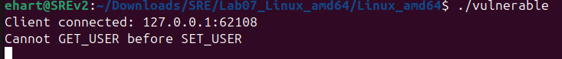
We see that this message responds to a function called GET_USER that fails if a user isn’t set. Upon further testing and setting a user, the server responds in this manner:

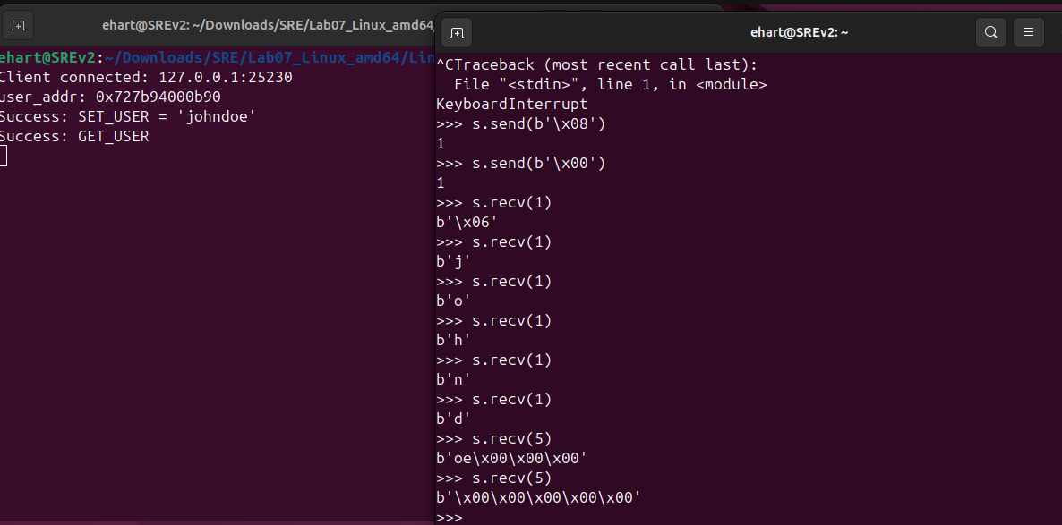
There are a few important things to note here. For one, we can confirm that this new function GET_USER of type 1 works after SET_USER is called. This is confirmed in the left terminal above. More importantly, we see that not only will the server return the user, but it will return as many bytes as we request. This functionality here is the key piece of the server we want to exploit: If we can request the server to return as much memory from user storage as we want, it may be possible to access a portion of the server’s memory that contains information that we weren’t supposed to see.

Testing the Exploit
To test this theory, we will need to do the following:
- Run the test_client.py various times to store valid credentials in the vulnerable server
- Create a copy of test_client.py (named my_client.py for this lab), and add the functionality for GET_USER
- Leverage my_client.py to attempt to receive a large number of bytes from the server until valid credentials are returned.

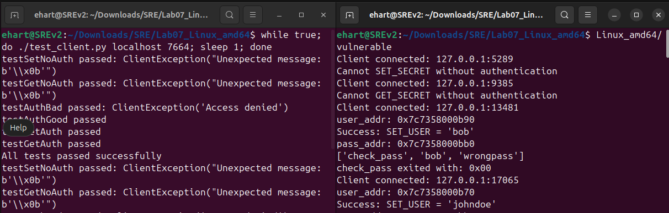
Figure 4: This figure demonstrates test_client.py populating the server with credentials.

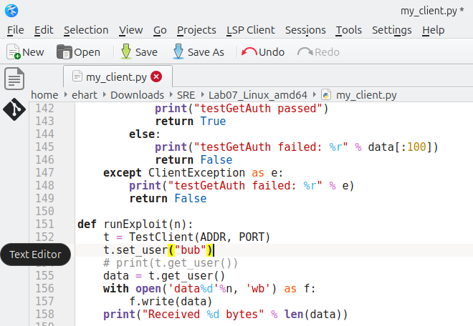
Figure 5: The file my_client.py running an exploit that uses a newly defined function get_user()

Now that we have the exploit ready, we can run it on the server, parse the byte responses into strings, and look to see if we grabbed any credentials:

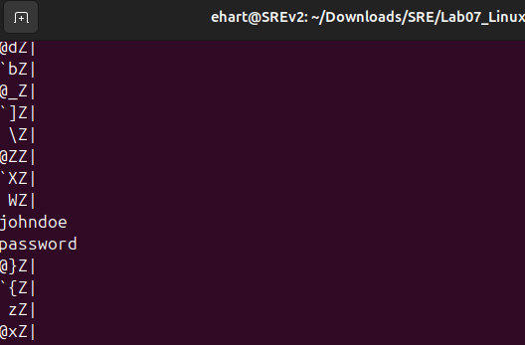
Figure 6: Output of my_client.py run on the local server, which was able to grab valid credentials.

Running on the Real Server
Now that we know our exploit works, we can run this on the real server at reclass.ddns.net. The solution I used to expedite the pulling of valid credentials was to create a thousand threads with a sleep timer after 500 threads were run so that the server had time to populate.

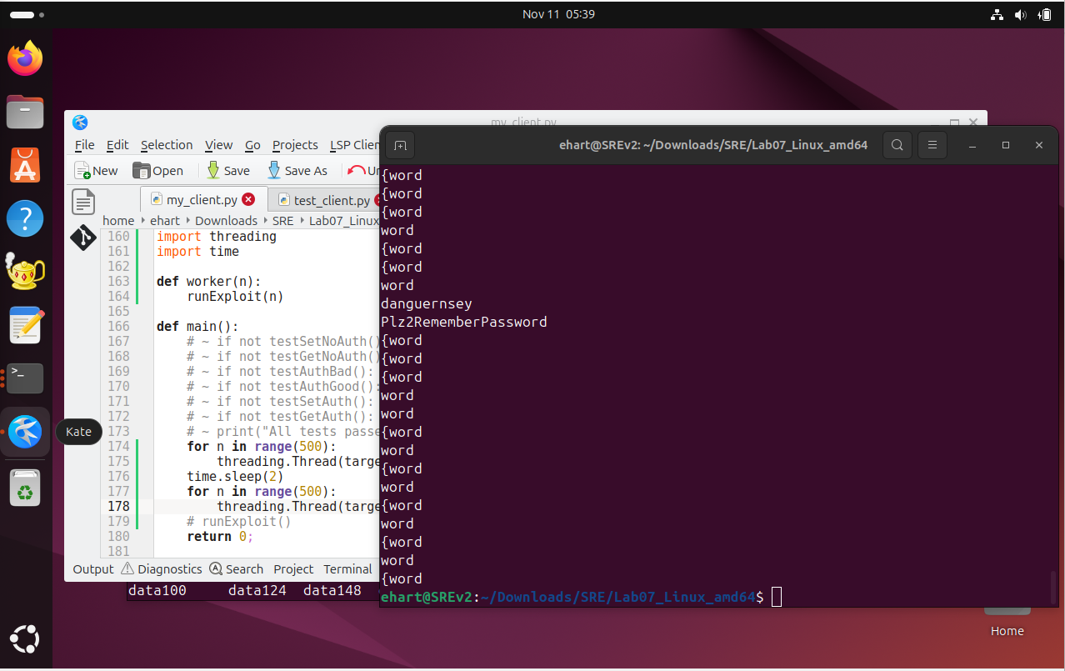
Figure 7: Output of my_client.py run on the server reclass.ddns.net, which was able to grab valid credentials.

Now that we have grabbed the username “danguernsey” and the password “Plz2RememberPassword”, we can modify my_client.py to authenticate with reclass.ddns.net and grab the secret.

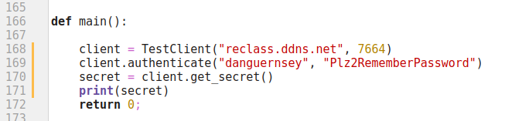
Figure 8: An updated version of main() in my_client.py to authenticate with reclass.ddns.net

Running my_client.py on reclass.ddns.net will return the following secret:
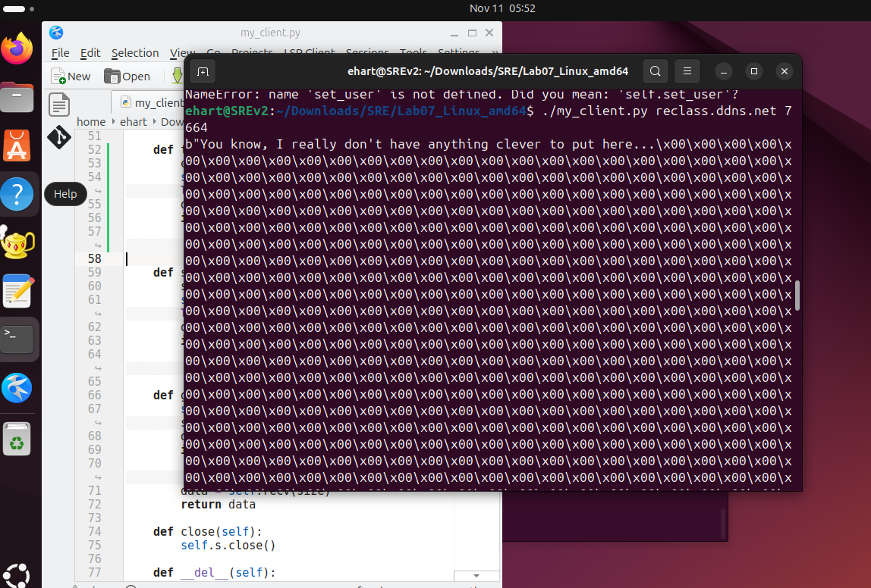
Figure 9: The secret revealed to us by the server

Conclusion
In this lab, we were able to discover an exploit in a server that allowed us to write a client that had the capability to steal another user’s credentials from the server. We then used these credentials to log into the server with the username “danguernsey” and the password “Plz2RememberPassword”. When we logged into the server, we were then able to retrieve the secret from the server, which was “You know, I really don’t have anything clever to put here…”.
This lab taught us the importance of how data flow is managed between a client and a server. Specifically, a user should usually never be able to specify how much data they want to receive from a server, and a server should implement bounds checking on buffers. We also gained insight into how one can derive exploits from source code, as the client was missing a function of a type that was most likely defined in the server’s code.

